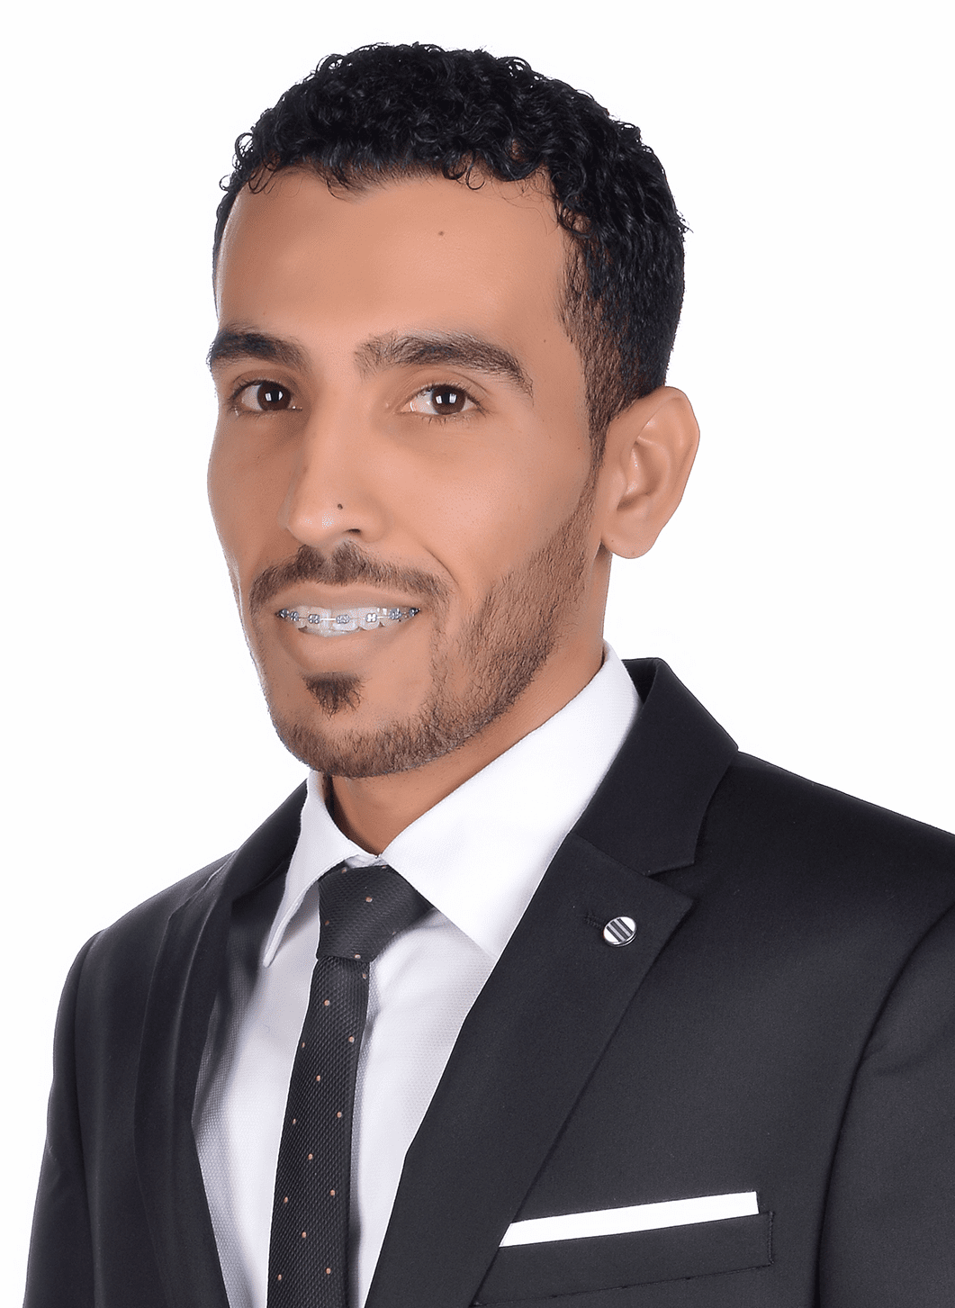CURRICULAM VITAE

Hussain Khalil Ebrahim

|  |
| --- |
| **Personal Information** |

**Date of Birth:** 12 September 1989

**CPR Number:** 890900426

**Nationality:** Bahraini

**Gender**: Male

**Marital Status:** Married

**Driving License***:* Available

**Address:** House 1034, Road 2431, Block 524 Barbar

**Contact Numbers**: Mobile 33111019

**Email:** [H7.7@LIVE.COM](mailto:H7.7@LIVE.COM)

|  |
| --- |
| **Introduction** |

A self-motivated and hardworking person, seeking for new challenging and motivating to develop my skills and gain my experience at a professional work environment.

I am a hard worker and capable of handling pressure, working independently and as part of a team, as well as managing several jobs simultaneously dedicated to achieve timely results at utmost quality.

|  |
| --- |
| **Education** |

**From 10 to 14 Sep. 2017 Bahrain Institute of Banking & Finance (BIBF)** (Project Accounting)

**From April 2015 to July 2015** [**AlGhad Training Institute**](http://www.gti.bh/)  (AAT Certificate)

**2012 – 2014** **Bahrain Training Institute** (Accounting - Diploma Degree)

**2010 – 2011 Bahrain Training Institute** Courses in Accounting (Accounting Technician)

**From April to July 2010** **Semester in British Council** (Course in English)

**2007 - 2009 University of Bahrain** (Business Administration)

**2004 - 2007** **Ahmed Al-Omran Secondary School** (commercial)

|  |
| --- |
| **Career history (Experience)** |

**June 2014- Present -** **Premator Gulf** (**Accountant**)

* Calculate and entry the invoices in Feedback system (Oracle System).
* Daily recording of financial transactions; sales and purchases, in terms of recipient and payment.
* Respond to customer calls to meet their needs, solve problems and find appropriate solutions that satisfy both parties.
* Handle and calculating petty expenses.
* Annual employee settlement account.

**June 2012- May 2014** – **Premator Gulf** (**Agent Clearance at LMRA, Ministries, Banks and Insurance Companies**)

* Clearing the transaction in government ministries (Immigration, LMRA, Foreign, Labor, and Tamkeen).
* Clearing Banks transaction (Deposit, Withdraw and Transfer).
* Dealing with companies: Receive and pay cheuqes.

**Oct. 2011-May.2012** - **Premator Gulf** (**Operator & Driver**)

* Operator for forklift, shovel and machines.
* Bring the workers to the company and return them back.
* Distribute the material and equipment on workers.
* Distribution of workers on the worksites.

**Aug. 2010-Feb.2011** Aluminum Alsubtain (Worker)

**Aug. 2009-Jan. 2010** Bedoon Waseet Magazine (Promoter & Distributor)

**2008-2009** Bus drivers (16 persons)

**2005 – 2008** Al-Barbari Building Center Material (Owner)

|  |
| --- |
| **Other Skills** |

* Accounting programs (Tally, Oracle and Peachtree).
* Data presentation using MS Office, MS Excel and MS Outlook.
* Good interpersonal and communication skills.
* Enthusiastic and willing to perform any assigned tasks.
* Excellent work ethic, well organized, team worker, self-directed and a quick learner.

|  |
| --- |
| **Interests& Hobbies** |

Football

Fishing

Swimming

I'm a young enthusiastic and ambitious, I search for a better job with new challenges and I hope to find this suitable job in your organization, with great respect and appreciation.

* * * *